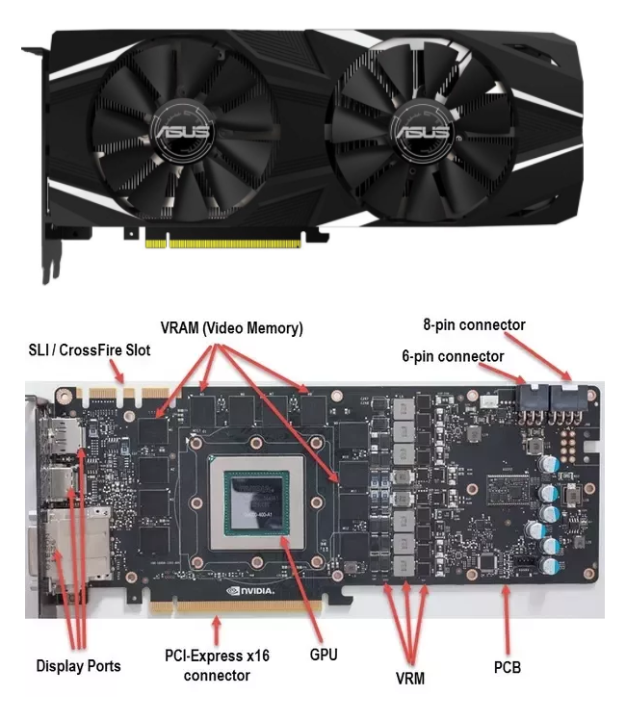

have a look at the photo above, it shows the different parts of a graphics card. so the top photo shows what's called the shroud basically the plastic that protects the Printer Circuit Board (PCB) inside.

8-pin connector – the 8 pin connectors are what provide power to the graphics card, they usually run on the 12 volt rail.

6 pin connector – some high end graphics cards will need two power cables, both 8 pin and 6 pin.

PCB – the Printed Circuit Board (PCB) is a bit like the motherboard but for a graphics card, it is what everything is connected too

VRM – the Voltage Regulator Module (VRM) is used to regulate how much voltage enters the GPU, it prevents surges of high voltages or low voltages. Insures there is always the exact right number of volts running to the GPU.

PCI-Express x16 connector – this is what connects the graphics card to your computer motherboard, it provides power to the GPU, it also acts as the data lines, allowing the GPU to send data to RAM if it needs too.

Display ports – these are the output ports such as HDMI, VGA, or DVI, this is where you connect your monitor to the graphics card.

And finally VRAM – Video Random Access Memory is where your GPU will stores frames temporarily after they have been rendered before being sent out of one of the display ports to your monitor.